  - Circles of Influence
Influence
Instructions: Place yourself in the large circle in the center. In the surrounding smaller
circles, list the major influences that make you the person you are. See the directions on the following page if Smart Art graphics are new to you.

Using the diagram:
Delete these instructions when you have completed your assignment.
This is a Smart Art Graphic.
- Click [Text], which opens a sidebar to type text.

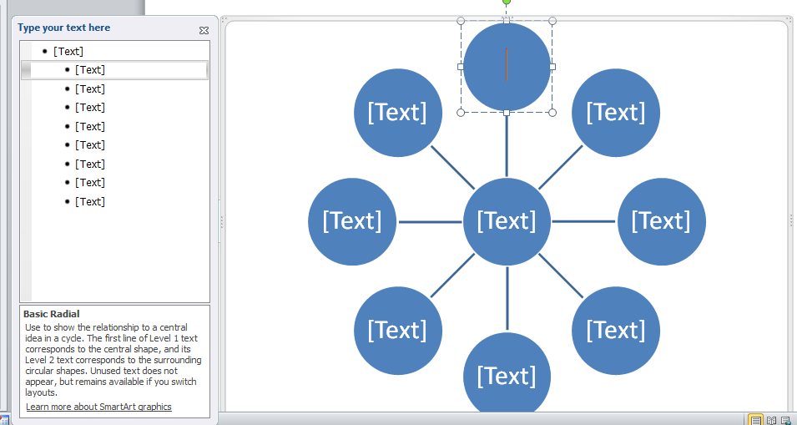

- Click the purple SmartArt Tools in the toolbar to access the toolbar to change the colors or formatting of the diagram. This toolbar will only show when you have clicked in the diagram.
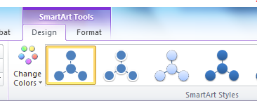
- In the future, to insert a diagram like this in a document, click Insert SmartArt
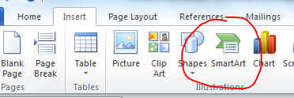

My Observations:

Replace this text to type your observations

References

